Application Assignment 1: Population Pyramids, Life Expectancy, and Cohorts
NAME: _______________________________
1. In Week 1, we reviewed population pyramids. For this question, you will compare the 2019 population pyramid of the United States to that of another country.
Go to the website: https://www.populationpyramid.net/
- The population pyramid that is currently shown is for the entire world. Change this to be the population pyramid of the United States. Do this by clicking the drop down arrow that is located beside “World 2019” and scroll down to select “United States of America”
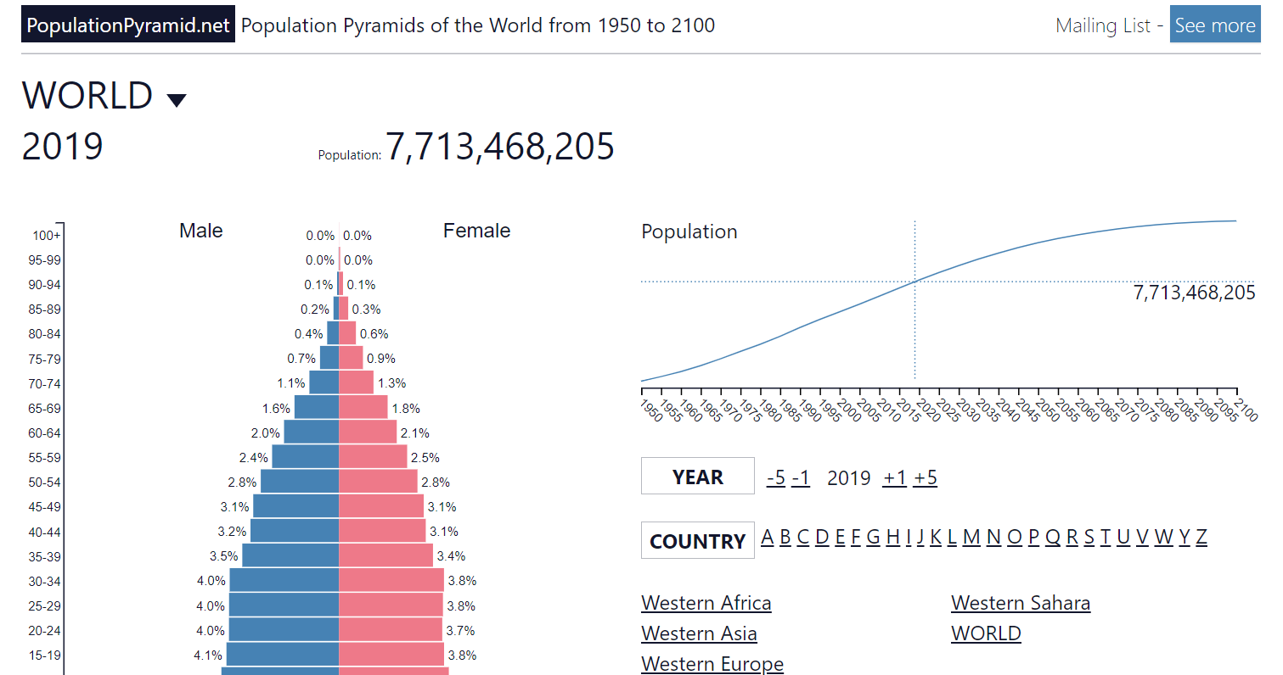

- Copy the 2019 population pyramid for the United States and paste it below. (One way to do this: Click “Download” (right below the graph). The population pyramid graph will then re-appear on your screen. Right click to copy it. Then paste it below. When you are finished, click the back arrow to return to the previous screen).
- You will then choose one other country (whichever one interests you!). Repeat the steps described above, but choose a new country.
1a) Copy the two population pyramids (United States and a country of your choosing) in the space below. (2 points)

1b) Based upon the population pyramids you copied above, which country’s population is relatively older? (i.e., has a higher proportion of older adults/ less of a triangle shape) (1 point)

2. A population is fast-growing when the size of each birth cohort increases each year (so the bottom of the pyramid is big and the pyramid narrows towards the middle). One thing to consider is how our population pyramid will be affected by the COVID-19 pandemic. Please read the following article:
https://www.cnn.com/2021/05/05/health/pandemic-births/index.html
Based upon this article, has the pandemic led to a baby-boom (i.e., rapid increase in birth rates) or a baby bust (i.e., rapid decline in birth rates) in the United States? (1 point)

3. How is life expectancy at birth different than life expectancy at a particular age?
(This was discussed in the video lecture, but if you need more help answering this, go to https://ourworldindata.org/life-expectancy-how-is-it-calculated-and-how-should-it-be-interpreted#commonly-we-study-life-expectancy-at-birth-but-life-expectancy-at-higher-ages-are-also-relevant :2 points)

4. Next you will look at how life expectancy at birth varies across countries.
Go to https://ourworldindata.org/grapher/life-expectancy?tab=map&region=World . You can hover your mouse over various countries to find out their life expectancy at birth.
In 2019, what was the life expectancy at birth in each of the following countries? (3 points)
Country | Life Expectancy at Birth in 2019
United States
Canada
Japan
Italy
Russia
Nigeria

5. Read the following article: https://www.npr.org/sections/health-shots/2020/11/19/911909187/in-u-s-cities-the-health-effects-of-past-housing-discrimination-are-plain-to-see
5a. What is “redlining”? (1 points)

5b. What is the relationship between redlining and life expectancy? (2 points)

6. Life expectancy also varies across parts of Atlanta. You will next learn more about this.
First, go to https://dsl.richmond.edu/socialvulnerability/map/#loc=11/33.766/-84.379&city=atlanta-ga
On the right hand side of the screen there is a map, with sections colored red and green.
*Click on one of the neighborhoods!*
After you do this, information about that neighborhood will show up in the center of your screen.
Scroll down until you see the information about “life expectancy”.
Describe what you learned from looking at this map. How much does life expectancy vary across neighborhoods in Atlanta? In what neighborhoods is life expectancy highest and in what neighborhoods is it lowest? (3 points)

7. Define and give examples of each of the following: (3 points)
 | Definition | Example
Normative age-graded influence

Normative history graded influence

Non-normative event

8. Generational cohorts are loosely defined based upon their birth year. For instance, people born in 1950 are considered part of the Boomers cohort. Take a look at the following table from the Pew Research Center.
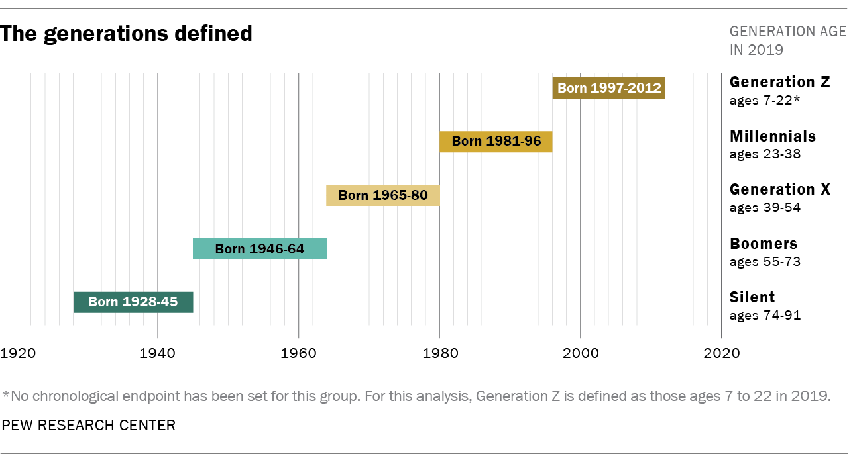
8a. Based upon this table, what cohort do you belong to? (1 point)
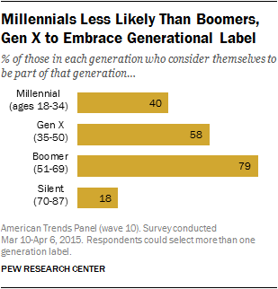
8b. Research has suggested that there are group differences in how strongly people self-identify with their cohort label (see graph). Do you personally self-identify with your cohort label? Why or why not? (2 point)

8c. What experiences or characteristics do you think makes your cohort the most different from your parents or grandparents’ cohort? (2 points)

9. There are many ways that cohorts differ from each other. Please read the following article describing how Millenials differ from older generations. After you have read the article, answer the questions below.
https://www.pewsocialtrends.org/essay/millennial-life-how-young-adulthood-today-compares-with-prior-generations/
9a. Based upon the article, briefly describe how Millenials differ from older generations for each of the following. (3.5 points)
How do Millenials compare to older generations in terms of… | Write a brief answer (1-2 sentences).
Educational attainment?

Employment trends?

Income and wealth?

Housing?

Families (marriage / children)?

Politics / voting?

Racial and ethnic diversity?

9b. Imagine that we are doing a cross-sectional study on religious beliefs, comparing people who are currently aged 65-75 (Boomer generation) to people who are currently 25-35 (Millennial generation). Results of this study show that the older participants have stronger religious beliefs than the younger adults.
Based upon this study can you conclude that people become more religious as they get older? Why or why not? (2 point)

10. In each of the following research designs identify the TWO factors that are confounded with each other. (1.5 points)
Which of the following TWO factors are confounded with each other in this design: Age, Cohort, Time of Measurement.
Cross-Sectional design
Longitudinal design
Time-lag design

